

INVITATION
- Name of the competition:
  - IVth International TAEKWON-DO Masters Mazovia Cup 2010
Taekwon-do MMC 2010
- Main Sponsor:
  - Marshal Office of Mazovia Voivoidship
- Support Sponsor:
  - Office of Ciechanow
- Honorary patronage:
  - Mr. Adam Struzik – Marshal of Mazovia Voivoidship.
  - Mr. Waldemar Wardziński – President of Ciechanow.
- Aim:
  - Promotion of Taekwon-do
  - Promotion of Ciechanow City and Mazovia Area in Poland and abroad.
- Organizer:
  - LKS Matsogi Ciechanów.
- Co-organzier:
  - Polish Taekwon-Do Association.
  - MOSiR Ciechanów.
- Term:
  - 20th November 2010.
- Weigh in and registration:
  - MOSiR Sports Hall in Ciechanow, 17-go Stycznia 60 Street (on 19th November)
- Venue of the competition:
  - MOSiR Sports Hall in Ciechanow, 17-go Stycznia 60 Street
Masters Mazovia Cup - MMC 2010

(Seniors, Black Belts, born min. 1992)

SENIOR FEMALE
- FEMALE PATTERN I DAN- VI DAN
- INDVIDUAL SPARRING
- FEMALE (I DAN – VI DAN): -58, -63 kg, +63 kg,
- FEMALE SPECIAL TECHNIQUES
- TEAM FEMALE SPARRING
SENIOR MALE
- MALE PATTERN I DAN-VI DAN
- INDVIDUAL SPARRING
- MALE (I DAN – VI DAN): -63 kg,-71 kg, -80kg, +80 kg;
- MALE SPECIAL TECHNIQUES
- TEAM MALE SPARRING
- PRE-ARRANGED SPARRING

Amateurish Mazovia Cup- AMC 2010
JUNIOR FEMALE (born: 1996- 1993)
- INDIVIDUAL JUNIOR FEMALE PATTERN 4 CUP- 1 CUP
- INDIVIDUAL JUNIOR FEMALE PATTERN I DAN- III DAN
- INDIVIDUAL JUNIOR FEMALE SPARRING
- Individual junior female sparring (4 cup – 1 cup): -45, -55 kg, +55 kg,
- Individual junior female sparring (I dan – III dan): -45, -55 kg, +55 kg,
- INDIVIDUAL JUNIIR FEMALE SPECIAL TECHNIQUES
- TEAM FEMALE JUNIOR SPARRING
JUNIOR MALE (born: 1996- 1993)
- INDIVIDUAL JUNIOR MALE PATTERN 4 CUP- 1 CUP
- INDIVIDUAL JUNIOR MALE PATTERN I DAN-III DAN
- INDIVIDUAL JUNIOR MALE SPARRING
- Individual male sparring (4 cup – 1 cup): -58kg,-63 kg, -70kg, +70 kg;
- Individual male sparring (I dan – III dan): -58kg,-63 kg, -70kg, +70 kg;
- MALE JUNIOR SPECIAL TECHNIQUES
- TEAM MALE JUNIOR SPARRING
SENIOR FEMALE (born min.1992)
- INDIVIDUAL FEMALE PATTERN 4 KUP- 1 KUP
- INDIVIDUAL FEMALE SPARRING
- Individual female pattern (4 cup – 1 cup): -58, -63 kg, +63 kg,
- FEMALE SPECIAL TECHNIQUES
- TEAM FEMALE SPARRING
SENIOR MALE ( born min. 1992)
- INDIVIDUAL MALE SPARRING 4 CUP- 1 CUP
- INDIVIDUAL MALE SPARRING
- Individual Male sparring ( 4 cup – 1 cup): -63 kg,-71 kg, -80kg, +80 kg;
- MALE SPECIAL TECHNIQUES
- TEAM MALE SPARRING
- Competition rules:
The championships will be played according to the rules of ITF and PTA
Patterns:
- The competition is played in the traditional „pyramid system”
- During the eliminations competitors perform only one optional pattern, whereas at semi-finals and finals two patterns: optional and designated.
Sparring:
- Sparring in each group is played in repasaże system
- Senior 2x2min( repasage 1x2 min), junior 2x1,30 min( repasage 1x1,30)

Team sparring:
- The competition is played in the traditional „pyramid system”
- Team must consist of three to six competitors
- Senior 1x2 min, junior 1x1,30
Special techniques:
- Competitors perform nopi ap cha busigi,
- Competitors are allowed to start performance at any hight
- Competitors may conduct two trials at each hight
Pre-arranged sparring:
- Performance shall last about 1 minute
- Mixed Male and female teams are allowed

- Rewards:
  - Cash prizes for I, II, 2x III places in individual divisions, only MMC
  - Financial awards for clubs in medal classification in MMC Competition
  - Medals for I, II, III places in each division - MMC and AMC
  - Cups for the clubs for I, II, III places- MMC and AMC
- Conditions of participation:
  - Entry fee :
    - 25 Euro per competitor for one division in MMC
    - 15 Euro per competitor for one division in AMC
    - 40 Euro per team in MMC
    - 30 Euro per team in AMC
  - In MMC and AMC can participate only competitors:
    - from the clubs being ITF members,
    - having min. 4 cup in AMC and min. I DAN in MMC
  - The Organizer has the right to collect an extra fee in the amount of 20 Euro for each competitor enrolled after deadline and for each change in the application
- Accommodation:
  - Hotel „Baron” Śląska 11, Street about 700 meters from the Sports Hall
  - Hotel „Olimpijski” 17-go Stycznia 60 Street,
  - - triple and quadruple roooms with a bathroom - 25 Euro per person per night.
  - - double rooms with a bathroom - 35 Euro per person per night.
  - - single rooms with a bathroom - 45 Euro per person per night.
  - The prices include full board
- Competition schedule:
19th November 2010 (Friday)
from 4.00 p.m - arrival
6.00 p.m - 8.00 p.m - weigh in and registration
8.30 p.m - 9.00 p.m - coach meeting
9.00 p.m - 9.30 p.m - umpire meeting
20th November 2010 r. (Saturday)
7.00 a.m - 8.00 a.m - breakfast
8.00 a.m - 9.00 a.m - weigh in
9.00 a.m - 4.00 p.m - competitors
4.00 p.m - 5.30 p.m - break
6.00 p.m - 8.00 p.m - Gala Taekwon-do MMC 2010
9.00 p.m - Party
- Other matters
  - The competitors have to be in possession of safety equipment: 10-unc. boxing gloves, kicks – foot safety pads, suspensory (male), doboks ITF.
  - There must be min. 4 competitors in each category/ division. In case if there are less than
4 competitors in category, the Organizer has right to cancel the category.
  - The Chairman of the Competition or the Organizer decide about the matters not written in this announcement.
  - There is possibility to arrange transport from the Warsaw Airport to Ciechanow and back, cost about 20 Euro per person.
- Applications:
  - The DEADLINE of sending the application is 24th October 2010. Please, send them to the addresses below: mkorzybski@wp.pl and info@pztkd.lublin.pl
  - THE COMPETITORS HAVE TO BE INSURED IN CASE OF AFTER-EFFECT OF UNFORTUNATE ACCIDENTS.
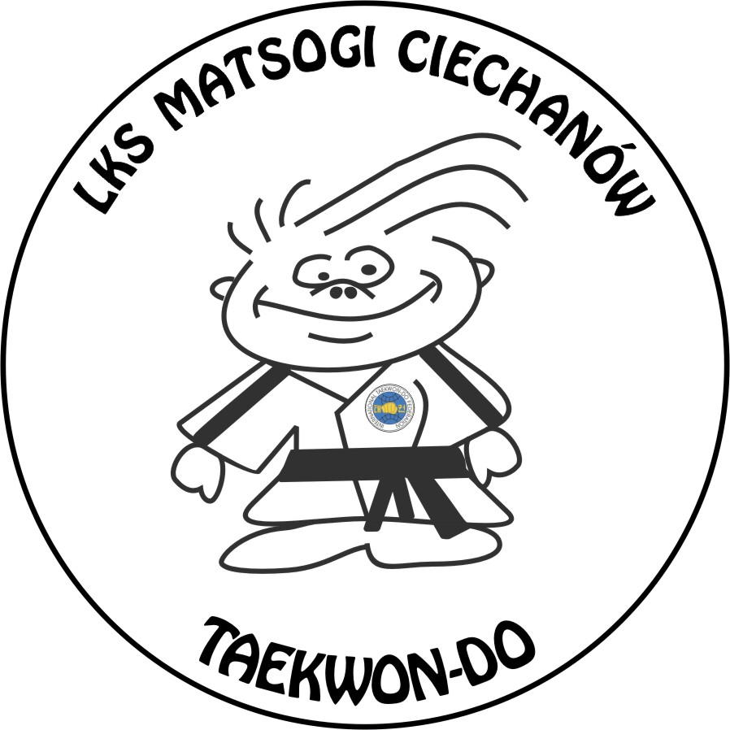
Looking forward to seeing you in Ciechanow!
Michał Korzybski Vth Degree
The Chairman of Organizing Committee

